Clever teenagers twice as likely to smoke cannabis due to their curious minds, study finds

[3 Comments](http://www.telegraph.co.uk/education/2017/02/23/clever-teenagers-twice-likely-smoke-cannabis-due-curious-minds/#comments)

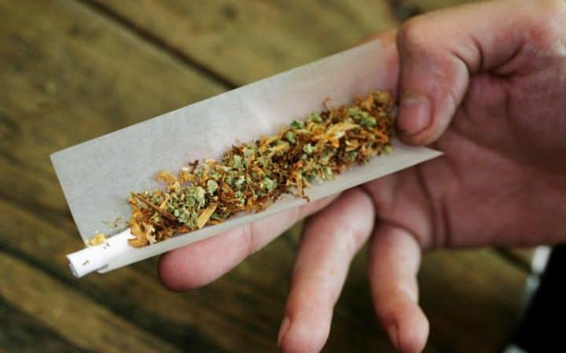Experts examined data for more than 6,059 young people  CREDIT: PETER DEJONG

* [Camilla Turner](http://www.telegraph.co.uk/authors/camilla-turner/), education editor

23 FEBRUARY 2017 • 6:00AM

Clever children are twice as likely to smoke cannabis as teenagers due to their curious minds, a landmark study has found.

Students who are high academic achievers at age 11 are also more likely to drink alcohol as teenagers, according to a nine year study by University College London (UCL).

Experts examined data for more than 6,059 young people from 838 state and 52 public schools across England. They found that bright children are less likely to smoke cigarettes as teenagers but more likely to smoke cannabis.

This could be because middle class parents pay more attention to health warnings about cigarettes, which they pass on to their children.

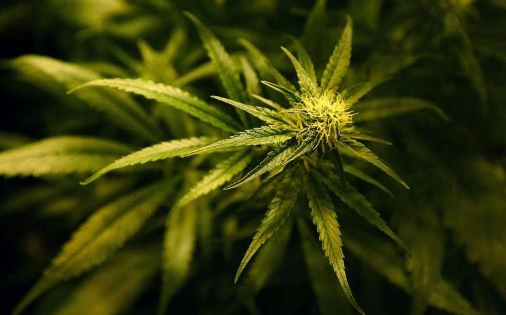

Scientists gathered information on the academic achievement of children at age 11 CREDIT: PA WIRE

Researchers found that clever children are more likely to smoke cannabis in their late teenage years because they have greater curiosity and strive to be accepted by older people.

They added that children who are "initially cautious of illegal substances in early adolescence as they are more aware of the immediate and long-term repercussions that breaking the law may incur than those with lower academic ability."

Scientists gathered information on the academic achievement of children at age 11 and compared it with their behaviour during early adolescence, defined as age 13-17, and then late adolescence, defined as age 18-20.

During their late teenage years, clever children were more than twice as likely to drink alcohol regularly and persistently than those who were not as clever.



Students who are high academic achievers at age 11 are also more likely to drink alcohol as teenagers CREDIT: PETER DAZELEY

Meanwhile, clever pupils were 50% more likely to use cannabis occasionally and nearly twice as likely to use it persistently than their less gifted peers.

Researchers found that these patterns persisted into adulthood and appear to contradict the notion that academic prowess was associated with a greater tendency to 'experiment' temporarily with these substances.

"High childhood academic at age 11 is associated with a reduced risk of cigarette smoking but an increased risk of drinking alcohol regularly and cannabis use," the researchers, from University College London, wrote.

"These associations persist into early adulthood, providing evidence against the hypothesis that high academic ability is associated with temporary 'experimentation' with substance use."

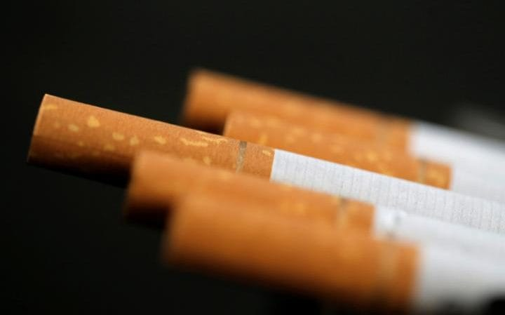

 Middle class parents pay more attention to health warnings about cigarettes, which they pass on to their children CREDIT: CHRISTIAN HARTMANN

The study, published in the journal BMJ Open, found that during their early teens, high-achieving pupils were less likely to smoke cigarettes than their less gifted peers. And they were more likely to say they drank alcohol during this period.

Dr James Williams at UCL Medical School said there has been a general downward trend in smoking cannabis and drinking alcohol among teenagers.

He added: “These risky health behaviours present a large problem in terms of public health as substance use is a risk factor for immediate and long-term health problems, as well as negative non-health outcomes such as poor educational and employment outcomes.

"The outcomes of cannabis use were found to be worsened by early onset and increased frequency of use.

"Understanding the risk factors for adolescent substance use can inform public health policymaking and help target interventions for those in high-risk groups."